**Vendor Performance Data Analytic Business Report**

Yufan(Krystal) Yao 9/17/2028

**Executive Summary**

This report presents a comprehensive vendor performance analysis aimed at improving profitability and operational efficiency within the retail and wholesale business context. Using SQL and Python for data extraction, cleaning, and exploratory data analysis (EDA), and Power BI for interactive dashboard development, this analysis delivers actionable insights into vendor and brand-level performance.

The analysis reveals that total sales reached $29.85M, with total purchases of $19.14M, generating a gross profit of $17.48M and an overall profit margin of 58.6%. A concentration risk was identified—the top 10 vendors accounted for 62.9% of total purchases, indicating dependency on a small number of suppliers. While several vendors such as Diageo North America Inc. and Martignetti Companies emerged as top sales contributors, a subset of vendors showed consistently low performance and profit margins, warranting further review and potential renegotiation of terms or promotional support. Similarly, brand-level analysis highlighted a few dominant high-performing brands driving most of the revenue, while numerous low-performing brands exhibited below-average profit margins and minimal sales contribution. This imbalance suggests an opportunity to optimize product assortments and reallocate inventory investments toward more profitable offerings. By pinpointing underperforming vendors and brands, this analysis enables decision-makers to:

•Focus marketing and promotional efforts where they will drive the highest returns

•Adjust bulk purchasing strategies to improve unit economics

•Reduce holding costs through better inventory turnover management

Overall, this project demonstrates the value of data-driven vendor and brand evaluation, providing a scalable framework to support strategic sourcing decisions and enhance profitability.

**Introduction / Background**

This analysis was initiated to address growing concerns about profitability, inventory efficiency, and vendor dependency within the retail and wholesale business context. Companies often struggle with challenges such as inefficient pricing structures, slow inventory turnover, and over-reliance on a limited number of suppliers.

These issues can result in higher holding costs, lower profit margins, and increased operational risk. To support data-driven decision-making and improve overall financial performance, this project focuses on evaluating vendor and brand performance through comprehensive sales and purchase data analysis. The primary objectives of this analysis are to identify underperforming brands that may require promotional or pricing adjustments, determine the top vendors contributing to overall sales and gross profit, analyze the impact of bulk purchasing on unit costs, assess inventory turnover to reduce holding costs and improve efficiency, and investigate profitability differences between high-performing and low-performing vendors.

By uncovering these insights, the analysis aims to inform strategic sourcing, pricing, and marketing decisions. This project involves several key stakeholders across the organization. Executive management will use the insights to guide strategic sourcing and vendor negotiation decisions, while the procurement team will rely on the findings to adjust purchasing allocations and contract terms. The sales and marketing teams can leverage the results to prioritize high-potential brands for promotional efforts, and the finance team will apply the profitability insights to evaluate return on investment from vendor partnerships. Additionally, the data analytics team plays a central role in maintaining data quality and enabling ongoing performance tracking.

The analysis covers one full fiscal year of sales and purchase data at both the vendor and brand levels, including metrics such as sales dollars, purchase costs, quantities, and profit margins. It assumes that the dataset is complete and accurate following the data cleaning process, though it does not account for external market fluctuations, seasonal demand shifts, or sudden supply chain disruptions. As such, while the findings provide a strong historical benchmark, they should be interpreted within the context of these limitations.

**Exploratory Data Analytic Insight**

**Summary Statistics**

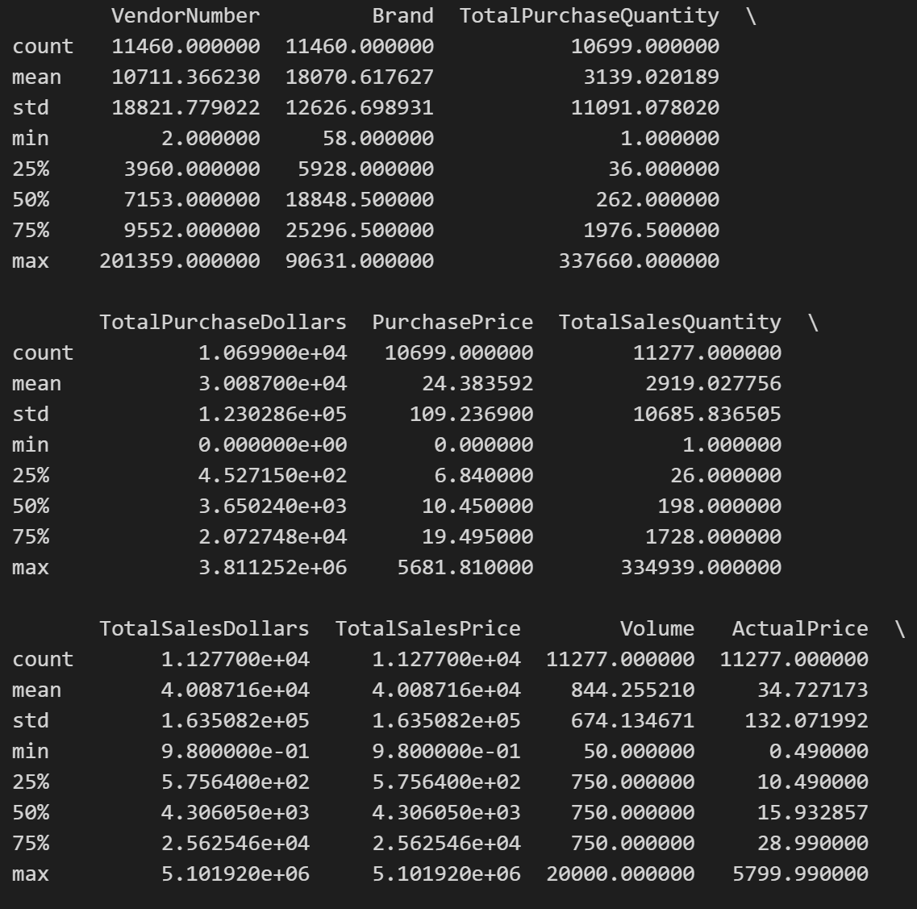

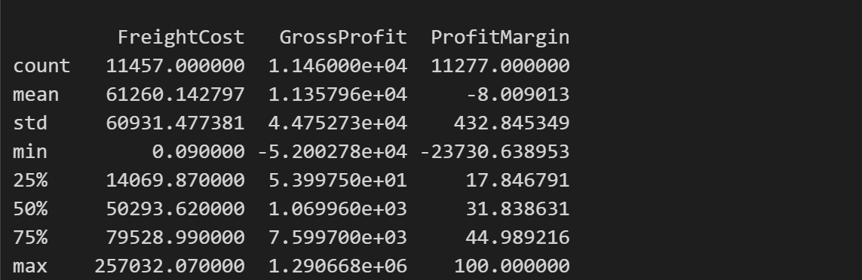

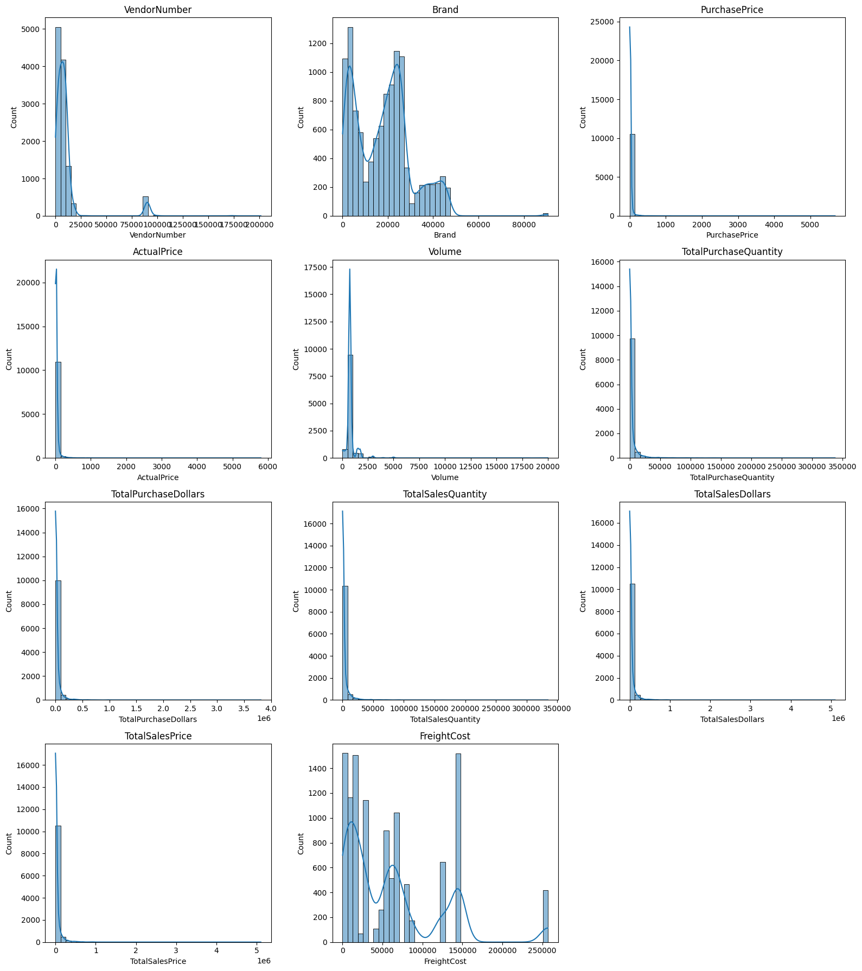

***Negative & Zero Values:***

1.Zero sales metrics: Both Total Sales Quantity and Total Sales Dollars show heavy mass at 0. That implies many vendor–SKU combos were purchased but didn’t sell in the period (slow-moving or obsolete stock), or sales weren’t recorded for those lines.

2.Zero purchase metrics: A cluster at 0 for Total Purchase Quantity/Dollars indicates items that sold without a matching purchase in-window (older inventory, dropship, or data gaps).

3.Pricing zeros: If any 0 values appear for Purchase Price or Actual Price, they’re data quality flags (missing price, returns netting to zero, or unit mismatch).

***Outliers & Spread:***

1.Prices (Purchase Price, Actual Price): Tight center around low double-digits with a long right tail and clear outliers (high-priced premium items or mis-keyed decimals). These points will dominate models unless capped or transformed.

2.Dollar totals (Total Purchase Dollars, Total Sales Dollars, TotalSalesPrice): Extremely right-skewed with rare, very large transactions—likely bulk buys, seasonal spikes, or key accounts. A log scale or historization is recommended for analysis.

3.Quantities (Total Purchase Quantity, Total Sales Quantity): Heavy right tail with many small transactions and a few very large ones. Those large points deserve review (promotions, case vs. unit counting, or one-off deals).

4.FreightCost: Very widespread with many small/zero shipments and occasional huge spikes. That pattern is typical of LTL vs. FTL shipments or consolidated loads; spikes may signal inefficiencies or surcharges.

5.Volume/Size: Mostly small pack sizes with a few very large ones. Consider normalizing

monetary metrics per liter/ounce to compare fairly across products.

6.Brand / Vendor Number: Distributions are highly concentrated with a few extreme codes, suggesting a long-tail vendor and brand mix (many small vendors, a few dominant ones).

**Data Filtering**

To enhance the reliability of the insights, we removed inconsistent data points where:

-Gross Profit ≤ 0(to exclude transactions leading to losses).

-Profit Margin≤0(to ensure analysis focuses on profitable transactions).

-Total Sales Quantity = 0(to eliminate inventory that was never sold).

**Correlation Insights**

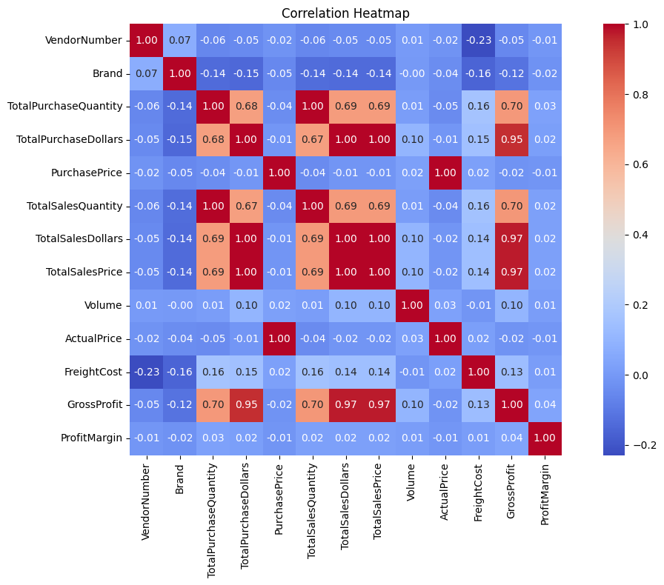

***Strong Positive Relationships***

1.Total Purchase Quantity, Total Purchase Dollars, Total Sales Quantity, Total Sales Dollars, TotalSalesPrice, and Gross Profit are all highly correlated (0.67–0.98).Higher purchase volume/dollars directly translate to higher sales and profit outcomes.

2.TotalSales Dollars vs. Gross Profit (0.98) – Revenue and profit move almost in lockstep, meaning profit is strongly driven by sales volume rather than cost efficiency.

3.Total Sales Price vs. Total Sales Dollars (0.98) – Price setting is a major driver of total revenue.

***Moderate Correlations Relationship***

1.Purchase Price vs. Total Sales Dollars (0.69) – Higher purchase costs are moderately linked to higher sales revenue, likely because more expensive products are being sold more.

2.FreightCost shows weak-to-moderate positive correlation with sales (~0.15–0.17) – Suggests that shipping costs rise as sales volumes grow, but not proportionally.

***Weak or No Relationships***

1.Vendor Number and Brand have little to no correlation with financial or volume metrics. It means Vendor/brand identity alone doesn’t predict sales or profitability.

2.Volume shows very weak correlations (near 0), meaning physical size/units don’t explain much about financial performance.

3.Profit Margin has weak negative correlations with Total Sales and Gross Profit (around -0.11 to -0.14).This Indicates that as sales increase, margin % tends to shrink (possibly due to discounting or higher costs).

**Research Questions & Key Findings**

1.Brands for Promotional or Pricing Adjustments

This analysis highlights brands that have high profit margins but very low total sales, making them candidates for promotional or pricing adjustments. The scatter plot shows most brands clustered at low sales with varying profit margins, while the red points (target brands) stand out above the high-margin threshold but below the low-sales threshold. The accompanying table lists these target brands, showing they each have profit margins around 40–66% yet very low total sales (under $50), suggesting untapped profitability potential if sales volume can be increased.

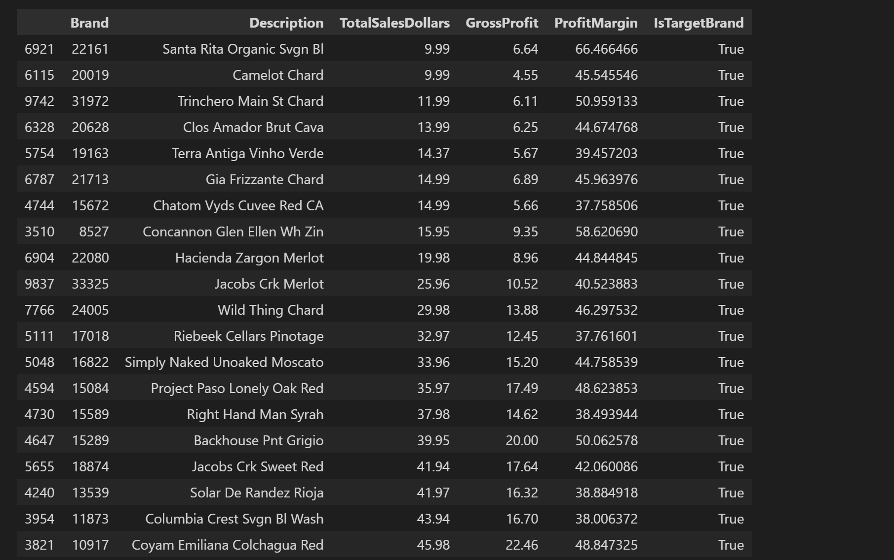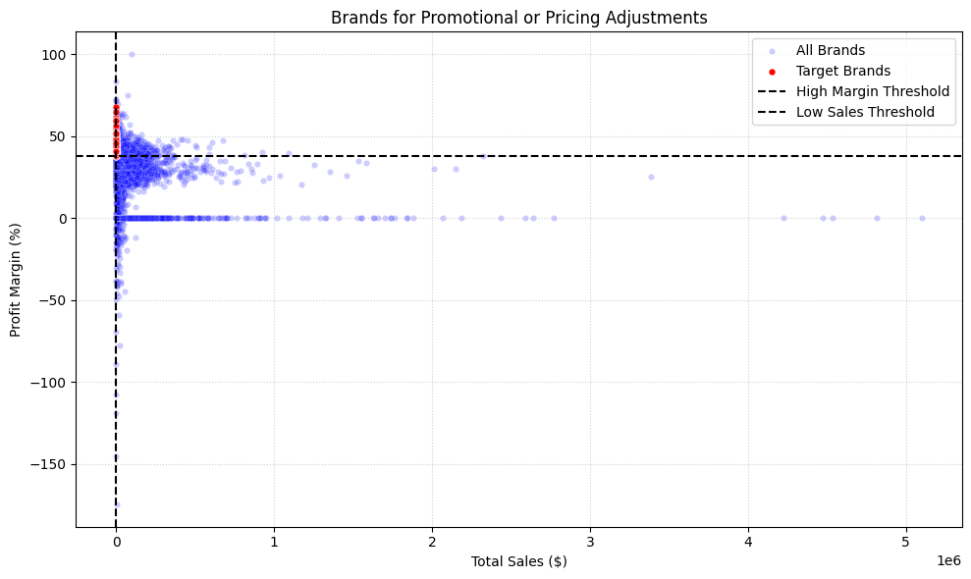

**Top Vendors by sales and Contributions**

This donut chart shows that the top 10 vendors collectively contribute 65.32% of total purchases, with Diageo North America Inc alone accounting for 15.8%. The remaining 34.7% of purchases are spread across all other vendors, indicating a moderately concentrated vendor base.

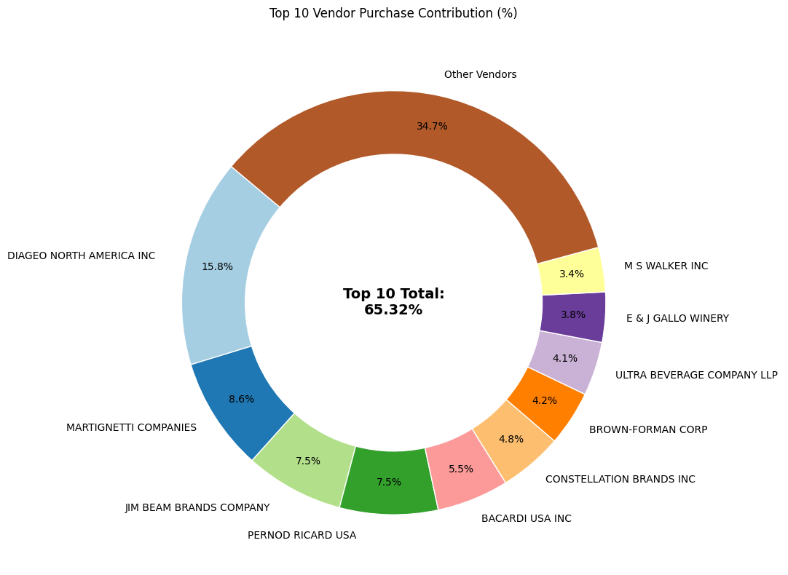

**Impact of Bulk Purchasing on Cost Savings**

This table shows that although all 43 vendors are represented across order sizes, the vast majority of purchases come from large orders (32,855,926 units). In comparison, medium orders account for 688,529 units and small orders only 39,922 units, highlighting a heavy reliance on large-volume purchases.

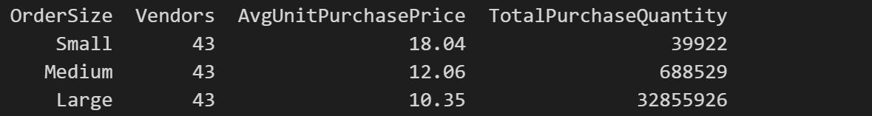

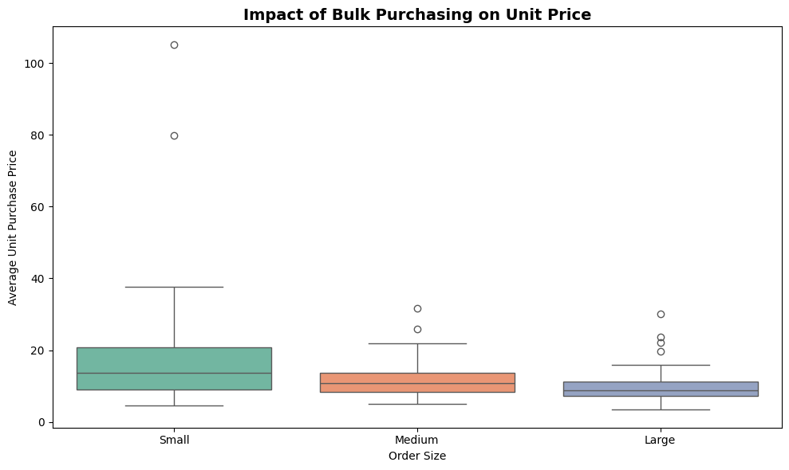

**Identifying Vendors with Low Inventory**

Turnover Total Unsold Inventory Capital: $79.70M

Slow-moving Inventory increases storage costs, reduces cash flow efficiency, and affects overall profitability. Identifying vendors with low inventory turnover enables better stock management, minimizing financial strain. 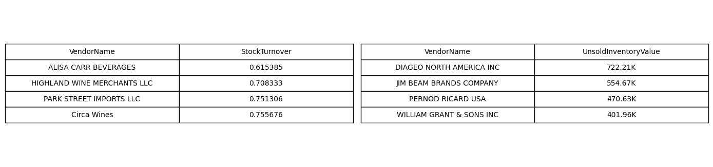

**Profit Margin Comparison: High vs. Low Performing Vendors**

The confidence interval for low-performing vendors (40.48% to 42.62%) is significantly higher than that of top-performing vendors (30.74% to 31.61%). This suggests that vendors with lower sales tend to maintain higher profit margins, potentially due to premium pricing or lower operational costs.

For High-performing Vendors: If they aim to improve profitability, they could explore selective price adjustments, cost optimization, or building strategies. For Low-Performing Vendors: Despite higher margins, their low sales volume might indicate a need for better marketing, competitive pricing or improved distribution strategies.

**Statistical Validation of Profit Margin Differences**

Ho(Null Hypothesis): There is no significant difference in the mean profit margins of top-performing and low-performing vendors.

H1(Alternative Hypothesis):The mean profit margins of top-performing and low-performing vendors are significantly different.

**Result:** The null hypothesis is rejected, confirming that the two groups operate under distinctly different profitability models.

**Implication:** High-margin vendors may benefit from better pricing strategies, while top-selling vendors could focus on cost efficiency.

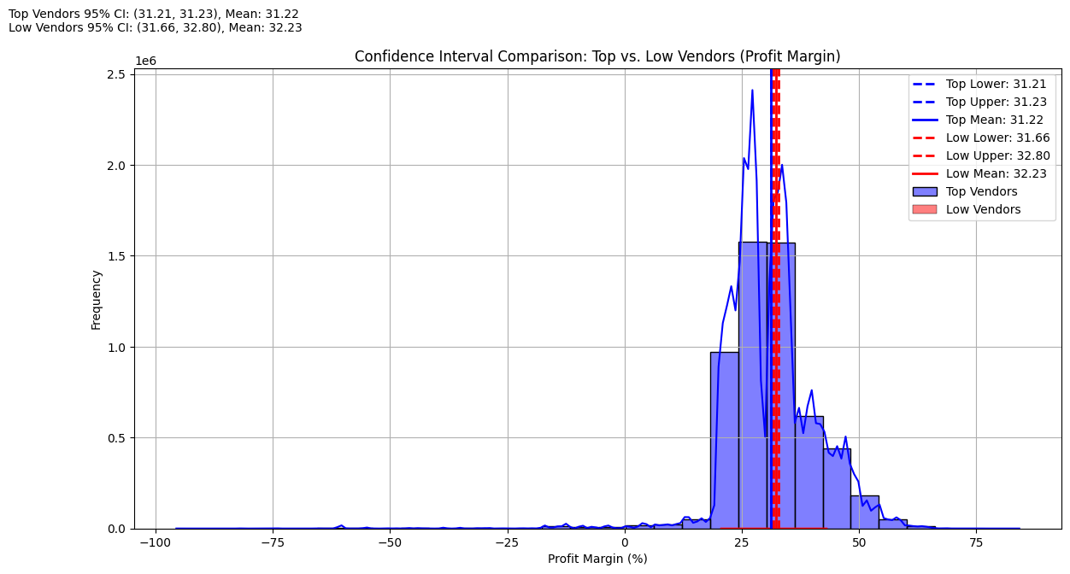

### 

### 

### 

### 

### 

### 

### 

### 

### **Final Conclusion**

This vendor performance analysis has provided a data-driven foundation for improving profitability, operational efficiency, and strategic decision-making within the retail and wholesale business context. By leveraging SQL and Python for data extraction, cleaning, and exploratory data analysis (EDA), and Power BI for dynamic visualization, the project transformed raw transactional data into actionable business insights.

The findings revealed significant concentration risk, with a small number of vendors driving the majority of purchases, and highlighted a long tail of underperforming vendors and brands contributing minimal sales at below-average profit margins. Conversely, top-selling vendors tended to operate on thinner margins, while low-selling vendors maintained higher margins, suggesting distinct pricing and cost structures that require tailored strategies. The discovery of slow-moving inventory and high unsold capital further underscored the need for improved inventory turnover and purchasing discipline.

Collectively, these insights enable leadership to prioritize marketing efforts on high-potential brands, renegotiate terms or offer promotional support for underperforming vendors, optimize bulk purchasing strategies to enhance unit economics, and improve cash flow efficiency through better stock management.

In conclusion, this analysis establishes a scalable and repeatable framework for vendor and brand evaluation—one that aligns operational choices with profitability goals. By continuously monitoring vendor and brand performance through this framework, the organization can proactively mitigate risk, capture new revenue opportunities, and sustain long-term competitive advantage.